## Authors –

How to Choose the Right Business Intelligence Technology to Suit Your Style

**Hitachi Consulting:**

John Lauer – Primary Author

Jeff Nelson – Supporting Author

Victor Rocca – Supporting Author

Harlan Smith – Reviewer

Derrick Nation – Reviewer

Hilary Feier – Reviewer

Liz Vitt – Reviewer

**Microsoft**:

Pej Javaheri – Reviewer

Revision history

Contents

Author – 1

Introduction 5

Self-Service Analysis 7

Description and Key Characteristics 7

Tool Options 7

Microsoft Excel 7

Microsoft SQL Server PowerPivot for Microsoft Excel 8

Typical Infrastructure 9

Key Considerations 10

Case Study 10

Customer Description 10

Business Problem 10

Tool Choice and Solution Architecture 11

Benefits Realized 11

Summary 11

Business Reporting 13

Description and Key Characteristics 13

Tool Options 13

Excel and PowerPivot for Excel 13

Microsoft SQL Server 2008 R2 Report Builder 14

Typical Infrastructure 16

Key Considerations 16

Case Study 17

Customer Description 17

Business Problem 17

Tool Choice and Solution Architecture 17

Benefits Realized 17

Summary 18

Parameterized & Operational Reporting 19

Description and Key Characteristics 19

Tool Options 19

MS SQL Server Reporting Services 20

Typical Infrastructure 21

Case Study 21

Customer Description 21

Business Problem 21

Tool Choice and Solution Architecture 21

Benefits Realized 22

Summary 22

Performance Monitoring (Dashboards) 22

Description and Key Characteristics 22

Tool Options 23

Excel Services / PowerPivot for Excel 23

Reporting Services 24

PerformancePoint Services 24

Typical Infrastructure 26

Key Considerations 26

Case Study 27

Customer Description 27

Business Problem 27

Tool Choice and Solution Architecture 28

Benefits Realized 28

Summary 28

Scorecarding 30

Description and Key Characteristics 30

Tool Options 30

Excel and PowerPivot for Excel 30

Reporting Services 31

PerformancePoint Services 31

Key Considerations 33

Case Study 33

Customer Description 34

Business Problem 34

Tool Choice and Solution Architecture 34

Benefits Realized 34

Summary 34

Conclusion 36

Additional Resources 38

This document is provided “as-is”. Information and views expressed in this document, including URL and other Internet Web site references, may change without notice. You bear the risk of using it.

This document does not provide you with any legal rights to any intellectual property in any Microsoft product. You may copy and use this document for your internal, reference purposes.

© 2010 Microsoft Corporation. All rights reserved.

# Introduction

Abraham Maslow was once quoted as saying “If you only have a hammer, you tend to see every problem as a nail.” Those words are truer than ever before as an increasingly complex and interconnected world makes selecting the right Business Intelligence (BI) tool crucial. Businesses, in an effort to stay one step ahead, collect large amounts of data ranging from demographics, buyer behavior, and customer loyalty to financial and operational data. Unfortunately the data is useless for decision making, its intended purpose, without a way of organizing and displaying it as meaningful information. To help digest and make sense of their data, companies need to select the proper tools that can collect, process, and present data in a relevant and timely manner. With the wide variety of tools available in the marketplace today, it is easy to get confused as to which to pick. But, just as a hammer is not appropriate for all jobs, no single business intelligence tool is appropriate for every user’s need. Companies need a way to determine which tools provide the most benefits to meet the varied needs of their users. The good news is that Microsoft provides a variety of tools that can address a broad range of BI styles, including Microsoft Excel, PowerPivot for Excel, SQL Server Reporting Services (including Report Builder), and PerformancePoint Services in SharePoint. All of these tools can be surfaced through the familiar SharePoint Server interface. For more information on the Microsoft BI tools, please visit <http://www.microsoft.com/bi>.

A BI style describes how users want to interact with, present, and share information. These styles are defined in part by a user's or group of users' unique information needs, along with the organization’s existing reporting capabilities, infrastructure, and skillsets of both business users and IT. This white paper discusses five different styles of BI reporting:

* **Self-Service Analysis** – Self-Service Analysis describes free-form reporting and analysis by users so that they can integrate data from disparate sources and drill-down and understand the root cause for data anomalies. These non-technical users value the ability to perform their own reporting and analysis without relying on IT or others.
* **Business Reporting** – This style describes formatted reports that are created by advanced business users or analysts. Reports are typically based upon approved corporate data, and then shared more broadly with managers, teams, or departments. In this style, IT involvement is moderate, usually overseeing the distribution and monitoring of the reporting environment and building of the structured data layer upon which the reports are built.
* **Parameterized & Operational Reporting** – Similar to the Business Reporting style, Parameterized &Operational Reporting is also characterized by fixed-format reports. The reports, however, are authored and managed by IT instead of business users and usually follow a pixel perfect format and rendering style. Consistency, scalability, manageability, and automated distribution are some of the key characteristics of this style.
* **Performance Monitoring** – This style describes dashboard-style reports that allow users to quickly and easily monitor the performance of their business. This style is catered to executive level or department leadership who require at-a-glance visibility on the health of the business, but it often also permits further investigation via interactivity.
* **Scorecarding** – Scorecarding is a style that describes highly summarized views with Key Performance Indicators (or KPIs) measured and scored against predefined targets such as a balanced scorecard. This style is generally a part of a performance management program, though it can also be used to measure operational performance.

This white paper provides readers a practical guide on how to identify both which BI style is being used as well as the tools that best fit each of the styles. The white paper outlines the following:

* The key characteristic of the BI style in the **Description** section.
* The **Tool Options** to consider along with the recommended “Best Fit” for the characteristics of the style
* **Infrastructure** considerations
* A **Case Study** highlighting how the “best fit” technology was used to support that style

By utilizing this information, the reader will be better prepared to make a tool decision and feel confident they are choosing the right tool or tools for their solution.

# Self-Service Analysis

## Description and Key Characteristics

The best analysts, and often the best assets, in most organizations are those users who love to dig into the data and really understand why the business is performing the way it is. Whether they are doing a financial modeling exercise to predict future revenue or drilling into sales data to understand why a store in the Southeast is outperforming all the other stores, these users are performing self-service analysis in Excel. This self-service analysis (reports, graphs, dashboards, and so forth) created by business users without reliance on IT is the “Self Service Analysis” style of BI. Some common characteristics of this style are:

* Users are very familiar with the business data and have strong Excel skills.
* Users want to easily drill down, pivot, filter, and format the data.
* Users are often integrating information from a variety of sources.
* Users are usually working with small-to-medium sized data sets.
* Users have minimal specialized technical skills such as SQL, MDX, or other query languages.
* Although the analysis might be shared with others, distributing the information on a regular basis is not typically the primary purpose of this style.

## Tool Options

Both Microsoft Excel and Microsoft PowerPivot for Excel 2010 are excellent tools for supporting the Self Service Analysis style.

### [Microsoft Excel](http://www.microsoft.com/bi/productsbi/#excel)

Microsoft Excel is the most widely deployed BI tool in the world for the Self-Service Analysis style. Virtually all power users are familiar with Excel, and this is a comfortable environment for collecting and analyzing data, and for developing reports quickly. Excel allows great flexibility regarding the types of analysis that can be done, giving users the freedom to integrate, calculate and explore the data quickly.

Excel reports can be distributed to others via email or published to SharePoint Server and viewed by using Excel Services in Microsoft SharePoint Server 2010. Excel Services is a Microsoft SharePoint Server technology that allows users to publish whole or partial Excel workbooks to SharePoint Server. This gives users access to the workbook or specific parts of it without allowing them to modify the workbook or calculations and thereby ensuring a single version of the workbook is maintained and viewed by all users. Users of an Excel Services workbook are also able to perform live, interactive analysis through any browser, including sorting and filtering of data, as well as expanding or collapsing of PivotTables. An Excel Services workbook has the added benefit of ensuring the right access and distribution of the workbook while maintaining a single version of the truth. Additionally, users can create distribution lists to automate distribution of the information, and they can use the versioning capabilities in SharePoint Server to facilitate collaboration. Alternatively, users have the ability to distribute the Excel workbooks via email for quick and easy sharing, though by this method every user can modify the workbook and maintaining a single version of the truth becomes more difficult. (We would recommend using Excel Services for this purpose.)

### [Microsoft SQL Server PowerPivot for Microsoft Excel](http://www.powerpivot.com/)

PowerPivot is a new product available as a free add-in to Excel 2010. PowerPivot for Excel builds on top of Excel functionality and adds additional features to empower the user for managed Self-Service Analysis. With PowerPivot, users can easily collect, interact with, and manipulate data from a broader range of sources, as well as work with data sets far larger than the Excel 2010 limit of 1 million rows per sheet. PowerPivot can scale to millions and even hundreds of millions of rows. The ability to handle this much data should easily meet the needs of almost any self-service BI analysis. However, bear in mind, PowerPivot is not well-suited for extremely large datasets and has a physical storage limit of 2 GB when compressed on disk. You can also use PowerPivot to prototype the solution quickly before involving IT in building more traditional BI infrastructure like a formal SQL Server Analysis Services cube. Additionally, users building PowerPivot models should have a good understanding of not just the different data sources, but also how the pieces of data relate to one another.

PowerPivot provides the ability to integrate corporate data with other data sources simultaneously, thus allowing users to create their own data solutions which otherwise would require IT involvement. It also allows PowerPivot models published to SharePoint Server 2010 to be scheduled for automated refreshes of the data. The PowerPivot infrastructure also allows larger numbers of users to consume reports or dashboards that have been published to SharePoint Server in a familiar web browser, such as the published PowerPivot model shown in Figure 1. Lastly, PowerPivot workbooks published to SharePoint Server also enable IT to monitor and manage usage of the models with a dedicated dashboard. End users that are provided access to the PowerPivot workbook are able to use the familiar Excel interface to query the data by using traditional Excel Pivot Tables or the Excel cube functions.

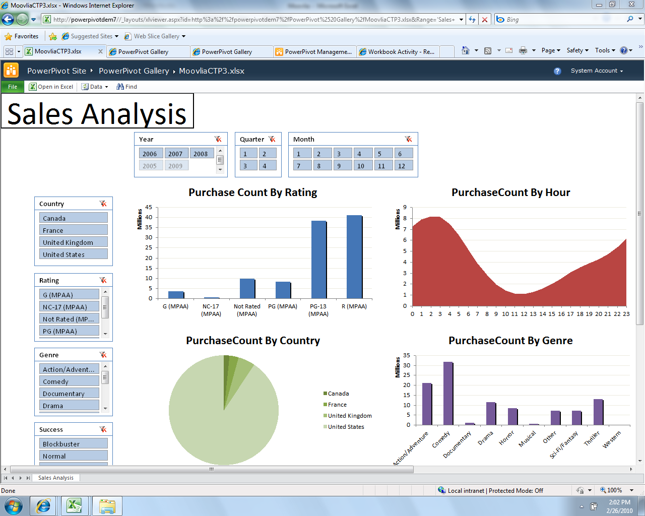

Figure 1 - PowerPivot Model Published to SharePoint Server 2010

## Typical Infrastructure

Infrastructure requirements for self-service analysis are minimal, and users can generally develop and share reports and information with little to no IT support, although IT infrastructure is a helpful mechanism for report distribution and collaboration. Because users often rely on, and are capable of, gathering data from multiple sources, the need for a structured corporate system to be built, such as a data warehouse, is reduced. Implementations of SharePoint Server with Excel Services or PowerPivot for SharePoint enabled allow more efficient management and distribution of the self-service analysis solutions. (It is important to note that Excel 2010 is required when implementing PowerPivot as the tool for this style.)

## Key Considerations

In order to guide you in how to best leverage Excel and PowerPivot for Excel for Self-Service Analysis, a list of questions is provided below to help describe best use of each technology’s capabilities.

|  |  |  |
| --- | --- | --- |
|  | **Excel alone** | **PowerPivot for Excel** |
| **How much data is being analyzed?** | Ideal for small to medium data sets (100s - approximately 1MM records) | Can handle large amounts of data (millions of records) |
| **Do you require asymmetrical or highly customized report layouts?** | Excel report layout and flexibility | Pivot Tables or Cube function to access PowerPivot data |
| **Do your power users have knowledge of data structures and relationships?** | This knowledge is not as critical because the free-form format allows manual integration of data as needed | Users need a firm grasp of how the data relates so proper linkages can be identified or verified |
| **Does your data need to be refreshed on a regular basis?** | Refreshing data is manual or requires macros | Data can be refreshed and updated automatically if published to SharePoint Server 2010 |

## Case Study

### Customer Description

Hitachi Consulting, the global business and IT consulting company of Hitachi Ltd., is a recognized leader in practical business strategies and technology solutions. Hitachi Consulting is an international management and technology consulting firm with headquarters in Dallas, Texas.

### Business Problem

A division within Hitachi Consulting involved in managing several large clients was faced with a need to gain better visibility into each of its projects in order to properly forecast and adjust to sudden changes. In order to achieve this visibility, this group needed access to additional data sources that did not exist in the corporate project tracking tools. The company already had a significant investment in a Microsoft BI platform and did not want to recreate existing data sources to achieve its reporting needs. Non-value–added work had to be done each month to get the data required to build these reports, and data was often inaccurate and outdated. Additionally, the division’s reporting needs were relatively low in the list of priorities for IT, driving the need to seek different alternatives.

### Tool Choice and Solution Architecture

The team chose to implement an Excel/PowerPivot solution to address its analytical reporting needs. The solution used the existing capabilities of SharePoint Server to capture additional metrics and PowerPivot to build the relationships between multiple data sources and reports. By leveraging these tools, the team was able to build reports using existing corporate metrics and enhance the project and account management reports to improve their forecasting abilities.

One of the main advantages provided by this solution architecture was the skillset of resources needed to build the solution. Unlike a typical BI stack solution where a full complement of developers and an analyst/designer are generally required, the team was able to build the solution with strong data analysts while only leveraging the firm's experienced BI resources for specific tasks. For example, BI expertise was needed for the data model design and advanced calculations (called DAX - Data Analysis Expressions – an expression language based on Excel formula syntax used in PowerPivot), and SharePoint Server expertise was needed for some of the capture mechanisms and workflows desired as part of the overall solution that was delivered. This solution was initially rolled out to approximately 20 users. It was so well received that the Operations Management leadership funded a next release of the PowerPivot model to expand the reporting capabilities and support adoption of corporate processes – which will result in onboarding another 50+ users. This release also paves the way for the model to be used more broadly in other divisions across the company.

### Benefits Realized

The division was able to benefit right away from this solution. Person-hours used to gather the data every month were phased out and the division gained operational efficiencies. With an automated refresh of the data, the team had better access to the information they needed in a timelier manner. Additionally, data quality problems were mitigated and communication with corporate billing was improved. Finally, by implementing this solution, the team was able to gain the visibility they needed to more efficiently manage their projects, allowing them to quickly adapt and plan when projects were not on track.

## Summary

Excel meets the basic needs of a power user wishing to perform quick analysis and easily create and share reports, and the familiar interface minimizes the learning curve and allows the user to focus on analyzing data quickly and easily. However, standalone Excel hits limits of scalability and does not allow for IT to manage the reporting environment. Excel 2010 used with the PowerPivot add-in and combined with PowerPivot for SharePoint provides this scalable and managed environment while still affording users the flexibility to acquire their own data and build and share their own reports and dashboards. The PowerPivot add-in also allows the user to acquire data from a variety of sources and integrate that data into a single unified dataset.

# Business Reporting

## Description and Key Characteristics

While typically not as fluid, fun, or “sexy” as the self-service creations discussed above, Business Reporting is just as important to organizations because of the need for power users in business functions to create highly formatted and distributable reports. Examples of these reports include sales order detail reports, inventory-on-hand reports, or sales attainment reports. Some key characteristics are:

* Data used to create reports comes from corporate sanctioned and IT managed data sources and the business user creating the reports is comfortable with the data.
* Reports are highly formatted and frequently printed.
* Reports are often shared broadly with other users.
* The reports are refreshed on a regular basis and available on-demand.
* Specialized technical skills such as SQL, MDX, or other query languages may not be required to author reports.
* Report consumers use only a browser to view and interact with the reports.
* End user interactivity with the published reports is limited to drilling down, drilling across, sorting, and filtering.
* Reports may be delivered in multiple formats such as PDF, Excel, HTML, and so on.

## Tool Options

Microsoft Excel and PowerPivot for Excel are suitable options for business reporting – particularly if collaboration is required when authoring/sharing reports, but the Report Builder component of SQL Server Reporting Services is the recommended tool if report distribution and management is a high priority.

### Excel and PowerPivot for Excel

As discussed in the Self-service Analysis style, Excel and PowerPivot for Excel provide functional and flexible report authoring environments. Often these tools are used for one-off analysis, but then that “one time” report ends up becoming a regularly accessed and distributed report. These reports may be highly formatted, which can be a tedious process in Excel and the refresh can be very time consuming. When the reports need to be refreshed and distributed on a regular basis, additional IT oversight and management is often desired. These are the scenarios in which Report Builder excels.

### [Microsoft SQL Server 2008 R2 Report Builder](http://www.microsoft.com/sqlserver/2008/en/us/report-builder.aspx)

Microsoft SQL Server 2008 R2 Report Builder 3.0 provides an intuitive report authoring environment for tech-savvy business users and IT professionals. It provides a full-featured reporting environment that allows users to develop highly formatted reports using an Excel-like ribbon. With fine grain control on formatting and pagination and advanced visualization options such as geospatial mapping, sparklines, and gauges – users can create sophisticated reports like the one shown in Figure 2 below.

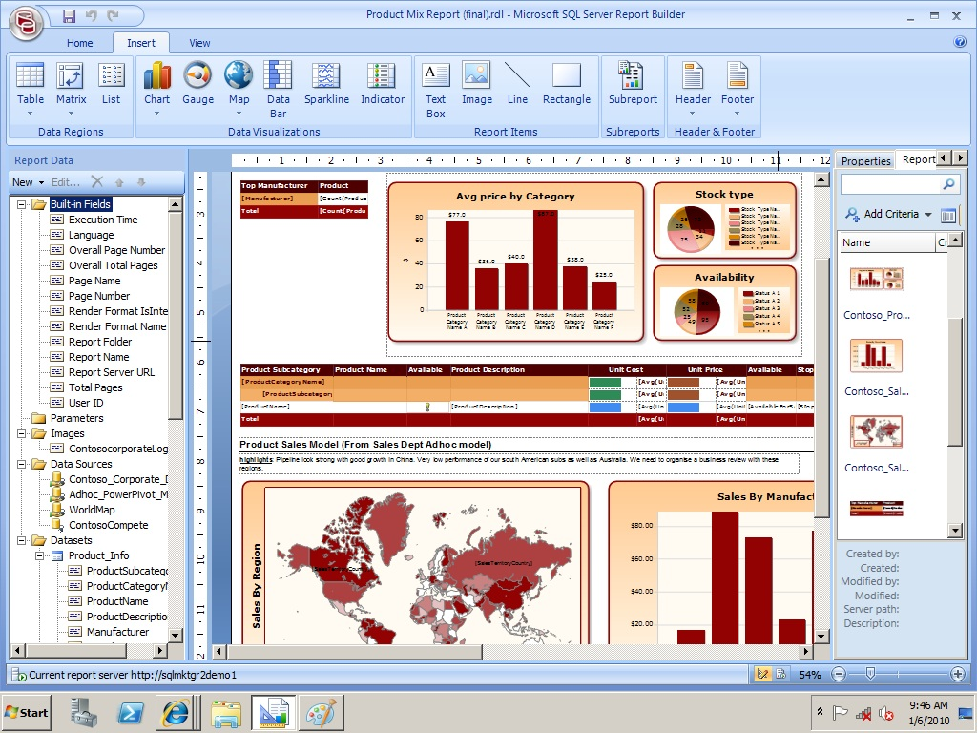

Figure 2 – SQL Server 2008 R2 Report Builder 3.0

These reports can easily be created with Report Builder because users have a wide variety of layout options such as tables, matrices, lists, charts, and gauges. The user can also design more interactive reports by adding parameters, interactive sorting on columns, and document maps. Report Builder 3.0 also enables advanced visualization techniques like sparklines and geospatial reporting, like those seen in Figure 3.

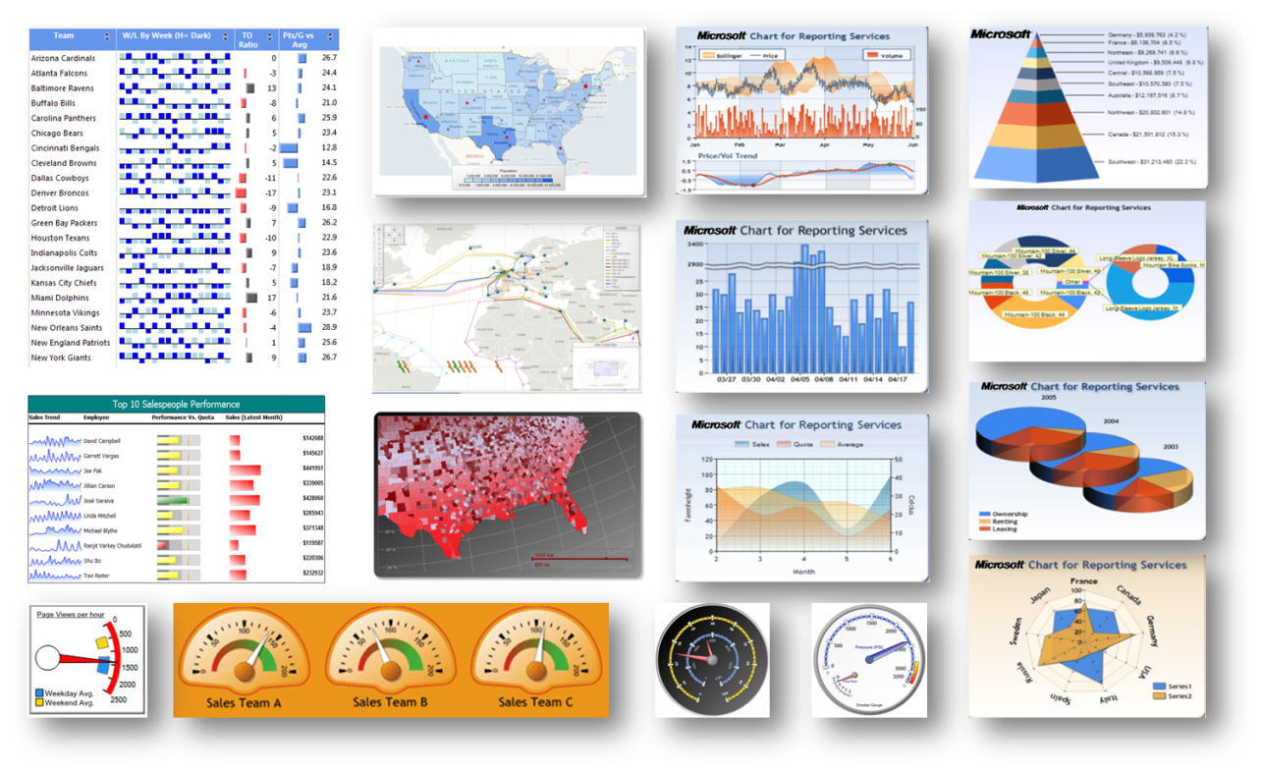

Figure 3 - Report Builder Advanced Data Visualization

One of the biggest advantages of Report Builder is that it supports the full capabilities of SQL Server 2008 R2 Reporting Services (SSRS), which allows seamless integration of business authored reports into the managed reporting environment. Because the published reports are SSRS reports, they can be fully managed by IT, as well as scheduled for automatic refresh and distribution using the robust SSRS report distribution mechanisms using Report Manager or enhanced through the integration with SharePoint Server.

Although users do not necessarily need to know how to write SQL queries to author reports with Report Builder, it does typically require a more specialized skill set than Excel or PowerPivot does.

## Typical Infrastructure

A data warehouse, data mart and/or online-analytical-processing (OLAP) environment is often in place and used as the data source for business user reporting. Report Builder is easiest for the non-technical user if a Report Model (that is, a business oriented semantic layer) is in place so they can understand and consume information without requiring knowledge of the underlying source tables. A SQL Server Reporting Services environment is required because Report Builder uses that environment. The Report Builder tool itself is deployed as a ClickOnce installation, so it is a lightweight installation which is always updated with the latest version.

## Key Considerations

In order to guide you in which technology to use for this style, a list of questions is provided below to help describe best use of each technology’s capabilities.

|  |  |  |
| --- | --- | --- |
|  | Excel /  PowerPivot for Excel | Report Builder |
| Is the data coming from a single data source or multiple sources? | Excel and PowerPivot for Excel both allow for easy access to a variety of data sources to be merged into a single table, chart, or other report. | Typically more suited to reporting using a single data source. Multiple sources are supported, but are typically assigned to separate report elements, such as separate tables or charts. |
| Are my reports detail level or more summarized? | Generally better for more summarized reporting (or shorter lists if detail level). | Can handle either with control of precise layout. |
| Is there a need for pixel-perfect formatted reports? | More difficult to maintain formatting over time as data changes. | Designed for creating and printing highly stylized pixel-perfect reports. |
| Do I need automated report distribution? | No push capabilities for automatic distribution of reports. | Reports reside in SSRS and can take advantage of robust report distribution, including data-driven distributions. |
| Do we need geospatial reporting? | Not available | Users can build geospatial reports with Report Builder 3.0 |

## Case Study

### Customer Description

Chevron is one of the world’s largest oil companies, with assets in more than 100 countries and employing 60,000 people. It is active in the oil, gas, and geothermal energy industries and manages oil refineries, wells, and power-generation facilities worldwide.

### Business Problem

Chevron employees wanted to have more control over the data analysis and reporting process. Because they had very knowledgeable and experienced subject matter experts, Chevron wanted to give them the ability to create their own reports and remove some of the burden from IT. Additionally, there was a need for creating reports that included mapping and spatial data for displaying BI data related to oil reservoirs, wells, and other operations. Finally, Chevron wanted this data to be highly available to users to help them in decision-making.

### Tool Choice and Solution Architecture

Chevron had an existing infrastructure of SQL Server which was updated to Microsoft SQL Server 2008 R2, allowing users to utilize the features of Report Builder 3.0. The need for visual reports was supported by Report Builder’s geospatial visualizations through mapping, routing, and custom shape creations. Additionally, data sets that already existed in SQL Server 2008 R2 Reporting Services were made available to users for creating their own reports using Report Builder 3.0.

### Benefits Realized

With the implementation of Report Builder 3.0, Chevron benefited by giving business users the ability to create and deliver better Business Intelligence reporting. Employees were able to perform their own BI analysis and report creation and as a result the burden on IT was greatly reduced. Furthermore, the spatial features of Report Builder 3.0 allowed the creation of new, improved data analysis reports, increasing the performance of one of its most critical business applications.

## Summary

While Excel and PowerPivot for Excel are both capable tools for meeting the needs of the business reporting style, Report Builder provides several advantages, including pixel-perfect reporting layouts for structured reports in an easy-to-use interface. Business users are also able to take advantage of existing SSRS infrastructure and scalability and utilize SSRS push distribution mechanisms. Finally, Report Builder provides advanced visualization capabilities such as geospatial reporting.

# Parameterized & Operational Reporting

## Description and Key Characteristics

Virtually all organizations have the need to distribute a fairly static set of information to large user communities. Reports such as daily, weekly, or monthly sales reports need to be distributed to the responsible parties for each store, region, or other organizational entity in a timely manner and without requiring user involvement to locate and run the report. The style that describes these centrally managed and distributed reports is “Parameterized and Operational Reporting”. Some of the key characteristics of this style include:

* Reports are usually authored by IT or BI developers, often because the complexity of the reports exceeds the capabilities of the user base for self-service reporting.
* Reports are often created with one or more user selectable parameters, but are not capable of extensive interactivity.
* Reports are refreshed regularly and distributed to users via email or via a portal if live interactivity is desired.
* Reports may be complex and require special technical skills such as advanced SQL, MDX, or other query languages to build.
* Data used to create reports comes from corporate-sanctioned and IT-managed data sources.
* Reports are shared broadly across the organization.
* Reports are highly formatted and may be frequently printed.
* Reports may be delivered in multiple formats such as PDF, Excel, HTML, and so on.

## Tool Options

While it is possible to address many of the characteristics of this style with several of the Microsoft BI tools, SQL Server Reporting Services is the best fit for this style since it handles all of the requirements and is the only tool that addresses automatic distribution of reports.

### [MS SQL Server Reporting Services](http://www.microsoft.com/sqlserver/2008/en/us/reporting.aspx)

Microsoft SQL Server Reporting Services provides a complete, server-based platform designed to support a wide variety of reporting needs, enabling organizations to deliver relevant information where needed across the entire enterprise. Through a powerful report authoring and management environment, Reporting Services enables IT to create and manage both static and parameterized reports and provides a solid platform for delivering information throughout the organization. The same report can be accessed via portal or automatically generated and distributed by Reporting Services.

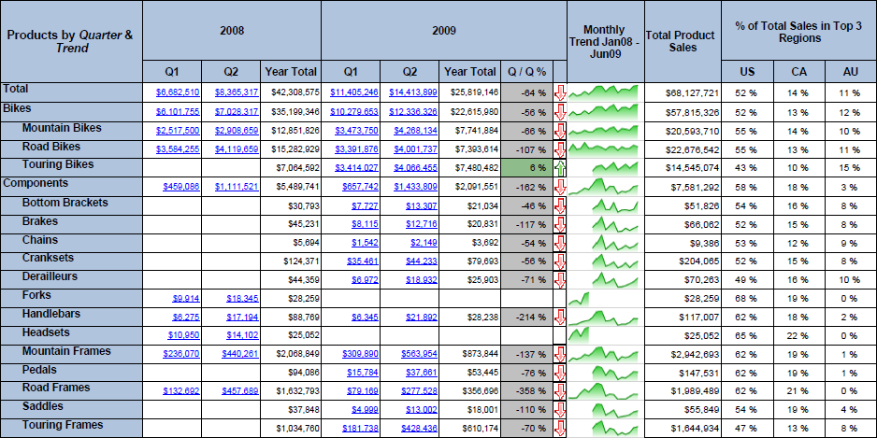

Figure 4 - SQL Server 2008 R2 Reporting Services

When the report is accessed via portal, the end user can interact and perform analysis through the use of parameters and filters embedded in the reports. With the use of parameters, drill-down, and drill-through capabilities, users are able to perform more guided reporting and analysis. Additionally, reports can be linked together to allow for more in-depth analysis via drill-through capabilities.

The report distribution components of Reporting Services allow automatic creation and distribution of the same exact report format to users or user groups with the data specific to their role. This allows reports to be scheduled and distributed throughout the organization using different delivery mechanisms and in different generation formats best suited to the user community. The reports may be delivered via portal, file share, email, or even sent directly to a printer, and may be generated as PDF, Excel, XML, comma delimited text file, TIFF image, HTML or Microsoft Word formats.

## Typical Infrastructure

For this style to be utilized effectively in an organization there should be an IT department in charge of creating and managing the corporate data sources such as data warehouses or data marts. The IT department should be experienced dealing with BI structures and reporting technologies and will be heavily involved in report development and management, including having a firm grasp on using the reporting tools and query languages such as SQL and MDX.

## Case Study

### Customer Description

The customer in this example wishes to remain anonymous, but is a large regional commercial bank in the southwest that delivers highly personalized financial services to businesses and private client individuals.

### Business Problem

The bank had limited visibility across all customers’ transactions, lines of business, and relationships. Additionally, transaction-level information on the various bank products existed in a multitude of different systems, resulting in a partial view of their overall customers’ relationship within the bank. The inability to develop a concise customer view across multiple lines of business was limiting the bank’s ability to identify opportunity for growth or new products. Rather than having applicable information automatically available to the Customer Relationship Managers (CRMs) to help serve the customer better and accordingly increase bank revenue, each CRM would spend tremendous amounts of time gathering data from different sources and arranging the data into their own unique formats.

### Tool Choice and Solution Architecture

In order to solve this problem, the client implemented a customer data warehouse to hold all its customers, accounts, and transactional information. The data warehouse consolidated 14 separate source systems into a single data repository. Reporting Services reports built on this consolidated data provided consistent reporting and information to all CRMs across the organization. Due to the sensitivity of banking data, this client chose not to automatically distribute reports to Customer Relationship Managers by using the data driven subscription functionality of Reporting Services. Instead, CRMs are able to run the report interactively when needed for analysis, and to create personal subscriptions to reports and receive the reports tailored to their parameters and preferences automatically on schedule.

### Benefits Realized

Microsoft SQL Server Reporting Services reports implemented on top of a new data warehouse introduced new sales capabilities by providing CRMs with the appropriate information at the right time.

The benefits of the combined customer reporting included solid and timely support to the CRMs to help them sell products more effectively supported by a consolidated view of all the products owned by a customer regardless of the source. It also helped them to grow business in specific asset classes and to generate additional revenue by strategically investing customers’ money into higher yielding products.

Through analytical reporting and the comprehensive view of products and services, CRMs were able to attract and retain deposits, increase loans as deposits allowed, and mitigate their risk through cross product line and cross industry exposure.

By being able to run these pre-created parameterized reports on their own without the need of an analyst, Customer Advisors could identify opportunities in a timely manner and act accordingly.

## Summary

Reporting Services is the clear tool of choice for Parameterized & Operational Reporting. By providing automatic report generation and distribution, and providing users with guided analysis of the data, Reporting Services leverages the capabilities of IT infrastructure and takes into account the varying expertise and desires of the user community, delivering a solution tailored to match each user’s needs.

# Performance Monitoring (Dashboards)

## Description and Key Characteristics

Just as a dashboard in a car helps a driver quickly understand the real-time operational performance of the automobile, a dashboard report helps business decision makers understand the current health of their business. A dashboard often combines key performance indicators from various business functions on a single page to help provide an at-a-glance view of performance and the ability to drill down further when something is off track or performing extremely well. This style is called “Performance Monitoring (Dashboard)”. This style is generally found in more mature BI environments where data points of interest have been defined, key determinants of business success have been identified, and a comprehensive BI strategy exists. The following are key characteristics that describe this style:

* Provides an at-a-glance view of business performance.
* Provides a more holistic view of the business or business function by combining multiple types of content together.
* Data in multiple formats are combined on one page. Some examples might include a tabular report with spark-lines, along with trended graphs or bar charts, and geospatial maps or scorecards.
* Users can drill down to perform root cause analysis for data anomalies.
* A corporate data platform is in place and includes an OLAP component, all being refreshed regularly.
* Often deployed broadly across the organization and various levels in the organization.

## Tool Options

A variety of tools can be used to create Dashboard reports to support this style of reporting. SharePoint Server is a common thread across all of the tools and the recommended platform for delivery of Dashboards. Because this style encourages using multiple formats combined on one page, it is not unusual to use more than a single technology to support this style. In this section we discuss all of Microsoft’s tools and focus on the benefits and trade-offs of using each technology choice.

### Excel Services / PowerPivot for Excel

Excel can be used to author dashboards, which can then be shared via two different methods. Excel Services uses a standard Excel workbook which is then hosted on SharePoint Server for viewing; however, it is limited in interactivity and is not designed for automated data refreshes. PowerPivot for Excel addresses both these shortcomings. It also adds the ability to easily consolidate data sources into a single dataset and allows you to work with much larger data volumes.

Because of the ability in Excel to easily incorporate sparklines, Red/Yellow/Green indicators, charts, and grids all on one page, it is a popular choice for Dashboards. Furthermore, as was mentioned in the discussion of the Self-Service Analysis style, Excel has the ability to integrate both IT managed sources and non-managed sources. This can prove valuable for incorporating elements onto the dashboard like industry competitive information that may not be integrated into the corporate data structures.

### Reporting Services

As described in the Parameterized & Operational Reporting Style earlier in the paper, Reporting Services provides a powerful report authoring design environment. One of the key features of that design environment is the ability to integrate multiple data sources and report styles on a single page. Reporting services supports sparklines, geospatial reports, charts, grids, and so on. Dashboards can be authored completely within Reporting Services, and drill-down navigation can be included through drill-down features and drill-through reports. Another benefit of authoring dashboards completely within Reporting Services is the enhanced printing and export abilities of Reporting Services, plus the report distribution capabilities. The downside of authoring in this environment is that drill-down navigation paths have to be pre-determined and pre-built, and the complexity involved in implementing most full-featured dashboards in Reporting Services will require the involvement of technical resources.

### [PerformancePoint Services](http://technet.microsoft.com/en-us/library/ee661741.aspx)

The PerformancePoint Services component of Microsoft SharePoint Server 2010 is a performance management service that is used to create dashboards and scorecards. By providing flexible, easy-to-use tools for building dashboards, scorecards, reports, and key performance indicators (KPIs), PerformancePoint Services can help users across an organization make informed business decisions that align with companywide objectives and strategy. PerformancePoint Services provides the ability to pull multiple view types into a single dashboard. In a PerformancePoint Services dashboard, users can interact with SSRS reports, cube-based graphs, performance maps, decomposition trees and Visio diagrams. Other content types can even be integrated by displaying any web page desired within a frame of the dashboard. As you can see in Figure 5, this flexibility in reporting gives users ample ways to navigate through the organization’s data and derive new information useful in making decisions.

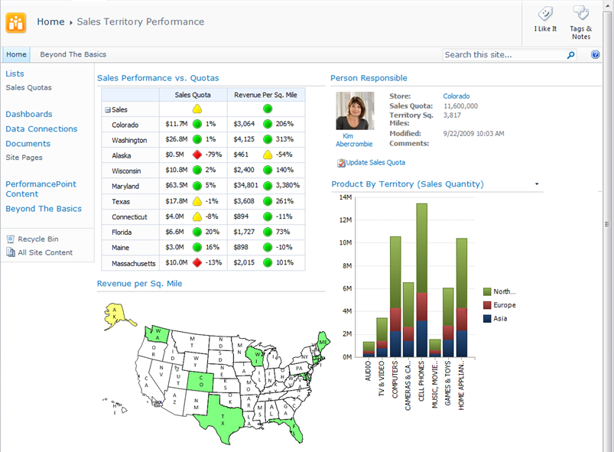

Figure 5 - PerformancePoint Services in Microsoft SharePoint Server 2010

Dashboard filters can be applied across the dashboard components, allowing users to update multiple or all parts of a dashboard simultaneously. With cube-based graphs and charts, users can perform ad-hoc analysis, slice and dice dimensional data, navigate through hierarchies, and pivot and change chart types quickly and seamlessly in just a few clicks. This type of analysis enables users to interact with the data and gives them the ability to arrive at answers that may not be available at first glance. PerformancePoint Services dashboards can incorporate data from a variety of sources, providing the capability to develop and manage the presentation of reports through one tool. In addition, report and dashboard development may be performed much faster by utilizing the structured layout and predefined design options available in PerformancePoint Services.

## Typical Infrastructure

The Performance Monitoring style capitalizes on existing data structures, often enterprise-wide, that serve as the repository for information from multiple data sources. The existence of OLAP cubes forms the foundation of BI analysis in these environments. Data is typically refreshed regularly on schedule to provide the most current information possible to the users. For these reasons, an IT department is required to deliver and support the BI needs of the organization.

## Key Considerations

The following table provides guidance on some of the trade-offs in using each of the technologies for this style.

|  | Excel Services /  PowerPivot for Excel | Reporting Services | PerformancePoint Services |
| --- | --- | --- | --- |
| How important is look-and-feel …    versus … | Requires Pivot Tables or CubeCell functions to get data from cubes. Full power of Excel for formatting. | Highly customizable. Can create complex reports. | Can lay out components as desired, but very little control over look of PerformancePoint components. |
| How important is interactivity? | PivotTable interactivity for slice-and-dice. | Not very interactive — typically more of a view-only type dashboard. | Extensive interactivity with dashboard items linked together, access to Decomposition Tree, slice-and-dice, change displays. |
| Is highly formatted printing needed? | Printing is possible but may require some work to setup print areas that are functional during drill down scenarios. | Reports can be configured for easy printing. Reports can also be exported to different file types (Excel, PDF, PowerPoint). | Printing and exporting to different file types is limited and can be difficult. Primarily designed for on-line viewing and interactivity. |
| Do I need to integrate non-corporate sourced data on the dashboard? | Easily integrate corporate and non-corporate data on same dashboard. | Limited ability for sourcing external data. | Possible to integrate both on same Dashboard, and can integrate data from Excel / PowerPivot and Reporting Services. |
| Does the dashboard need advanced visualizations? | Limited to Excel Pivot Graphs. | Provides ability to include SSRS Geospatial visualizations, charts and gauges. | Can combine data from various sources including: Visio Services, Decomposition Trees, Geospatial, weighted Scorecards, and KPIs. |

## Case Study

### Customer Description

Charlotte-Mecklenburg Schools (CMS) is a local education agency headquartered in Charlotte, North Carolina and is the public school system for Mecklenburg County. With over 133,600 students enrolled, it is the second-largest school district in North Carolina and the twentieth-largest in the nation.

### Business Problem

CMS was tracking performance manually, and only a few times a year. The Board of Education would ask for custom, ad-hoc reports that required significant district resources to produce and that offered very little transparency into program effectiveness. With limited resources, rapid growth, and hundreds of different programs, CMS was finding it difficult to get real-time access to performance data so that it could make better decisions.

### Tool Choice and Solution Architecture

CMS chose to implement a dashboard solution by using PerformancePoint Services. A series of dashboards were deployed to a publicly accessible SharePoint site, allowing the Board of Education, the central office, and parents to monitor whether improvement efforts were on track. These dashboards take advantage of the abilities of SharePoint Server and PerformancePoint Services to combine scorecards, dashboards and reports into a consolidated view. Data for the dashboards is sourced from CMS’s data warehouse, Excel spreadsheets, and departmental and organizational systems.

### Benefits Realized

CMS was able to quickly benefit from implementing this solution in several ways. Users have the ability to track CMS progress towards each goal, allowing them to make better decisions about which initiatives to pursue. The Board of Education and district workers can analyze and compare performance data along many dimensions, such as race, income level, and English-language proficiency. By deploying the tool internally and out to the district’s constituents – a community close to a million members – CMS was able to increase transparency district-wide as well as throughout the community. Additionally, real-time snapshot information allows the Board of Education to see whether CMS is likely to meet, exceed, or fall short of its performance goals – and make timely adjustments to stay on track. Finally, the PerformancePoint Services solution provides CMS with the scalability and affordability needed to support their aggressive growth goals

## Summary

Many tools can be used to support the Performance Monitoring style, and each tool comes with its own set of benefits and trade-offs. While the choice of which dashboard tool to use will depend upon how each measures up against the specific set of requirements, SharePoint Server is the common denominator across all the tools and provides a single point of entry for the Performance Monitoring style.

Excel provides a business-friendly report authoring environment and provides the ability to integrate data in your dashboards that may or may not exist in the corporate IT platform. Through the use of Excel Services and PowerPivot for SharePoint, it is also the simplest for business users to create their own dashboards without IT involvement.

Reporting Services provides the advantage of greater layout flexibility when developing Dashboard reports and provides excellent printing capabilities. Reporting Services allows greater report structure for guided navigation, although this may be viewed as a strength or weakness depending on how sophisticated the end users are and how much leeway you wish to provide them to analyze on their own.

PerformancePoint Services provides the most interactive and flexible data analysis capabilities. Charts and graphs in a dashboard can be connected to interact with each other, and filters can be applied to multiple reports on the same page that have been created in different technologies. Ad-hoc interactive analysis is quick and easy when the source is an Analysis Services cube. The flexibility in a PerformancePoint dashboard limits the formatting options when printing, but empowers users to analyze the data and find new and different ways of displaying the information.

# Scorecarding

## Description and Key Characteristics

Just as baseball fanatics diligently keep stats on their favorite players and teams and monitor key indicators on their achievement, organizations do the same on the clearly articulated set of metrics that measure and monitor businesses performance in achieving their strategic objectives. “Scorecarding” describes this BI style in which users measure enterprise-wide performance against organizational goals, and where the timely presentation of trends and Key Performance Indicators (KPIs) is critical in driving business decisions.

The following characteristics describe this style:

* A small number of key performance indicators (KPIs) are identified and monitored against articulated targets.
* The relative importance of KPIs is known and weighted to provide an overall “score” for an organization, department, or individual’s performance.
* Business objectives and their related KPIs are presented hierarchically and can be filtered to help determine root causes of outliers.
* A corporate data platform is in place and includes an OLAP component, all being refreshed regularly.
* The scorecard is often broadly deployed and can be easily consumed and navigated with a browser.

## Tool Options

As with the Performance Management style, virtually all of the Microsoft front-end tools can be used to create a Scorecard style report and each tool comes with benefits and trade-offs which have largely been discussed in other Styles. However, of the group, only PerformancePoint Services is a true scorecarding platform and therefore is the recommended tool for creating scorecarding solutions.

### Excel and PowerPivot for Excel

Excel and PowerPivot for Excel can be utilized to create free-form scorecard style reports; however, it requires extensive development to build a comprehensive scorecard solution.

### Reporting Services

Like Excel, Reporting Services is a great choice for creating reports that look like a scorecard, but it requires more immersive development to create weighted indicators or multiple rollup types that are required for a full-featured scorecard solution.

### PerformancePoint Services

PerformancePoint Services is a component of SharePoint Server 2010 and provides a platform for designing and building both balanced and free-form scorecards. Balanced Scorecards refer to a strategic planning and management system that was made famous in the early 1990s by Kaplan and Norton when they wrote the book “Balanced Scorecard: Turning Strategy into Action.” The balanced scorecards focus the organization on finding a balanced set of metrics across multiple perspectives – balancing the typical lagging financial indicators with a broader set of leading indicators that better predict future performance. Balanced and Free-form scorecards along with Strategy Maps allow organizations to provide a concise vehicle for communicating overall company performance against well-defined targets. A major benefit of scorecards is the ability to aggregate and display non-like data into unified and summarized scores.

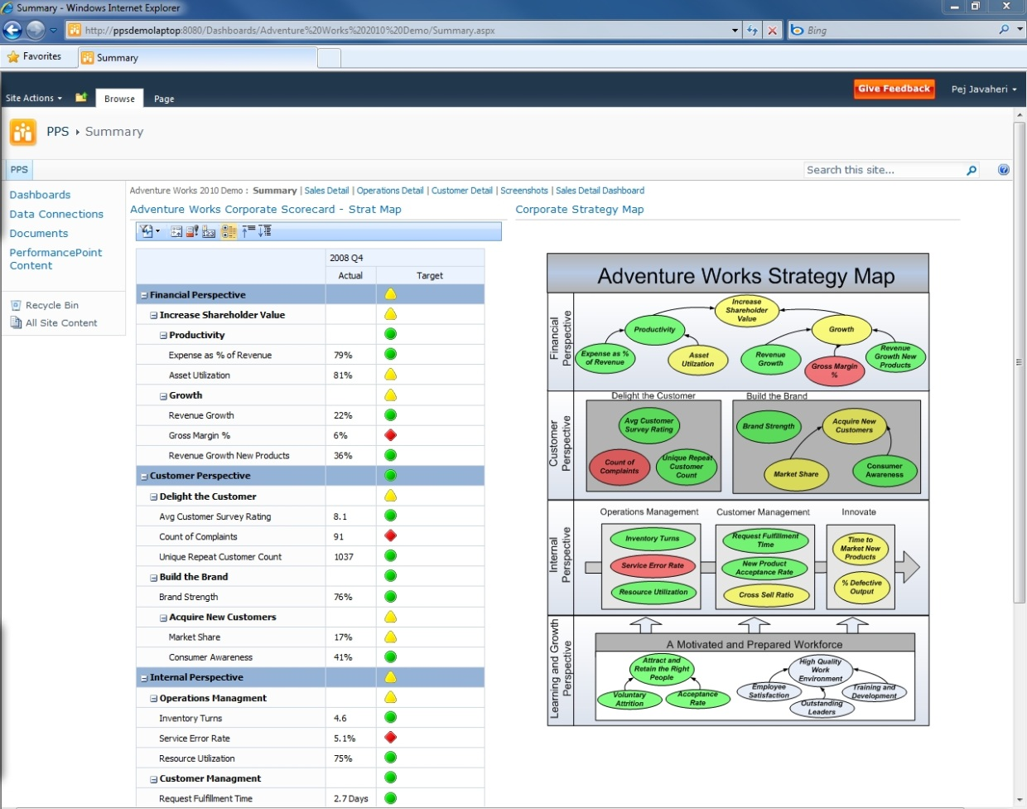

Figure 6 - Scorecarding with PerformancePoint Services in Microsoft SharePoint Server 2010

As in Figure 6, PerformancePoint Services allows companies to set up hierarchical KPIs with relative weightings that align with perspectives and objectives. Targets can be defined at each intersection and ranges can be set for defining Red/Yellow/Green status thresholds for each KPI. Because PerformancePoint Services is a part of SharePoint Server 2010 – the Scorecards are easily shared and distributed. Scorecards can also be pivoted and filtered by a number of dimensions, allowing users to perform root cause analysis on KPIs that are not meeting the targets. Scorecards are often displayed as a component within in a Dashboard and leverage the full-power of the Performance Monitoring Style by interacting with other reports in the dashboard.

## Key Considerations

PerformancePoint Services is the preferred platform for full-featured scorecards; however, all of Microsoft’s BI tools can be used for this style if creating “scorecard style” reports is the main objective. The following table discusses the key considerations that differentiate the tools for this BI style.

**Note:** Refer to the Key Considerations of the “Performance Monitoring (Dashboard)” style to evaluate the other aspects of the tools. That analysis is not discussed here to avoid repetition, because the Scorecard style is essentially always presented as a component of a dashboard.

|  |  |  |  |
| --- | --- | --- | --- |
|  | Excel Services /  PowerPivot for Excel | Reporting Services | PerformancePoint Services |
| Informal Scorecard style reporting | Yes – Scorecard Style reporting. | Yes – Scorecard Style reporting. | No –KPIs defined on formal data sources or in PowerPivot for Excel first. |
| Does the Scorecard require true Scorecard Platform capabilities ? | No – Scorecard Style reporting Only. | No – Scorecard Style reporting Only. | Yes – Can define KPIs, custom aggregations, weightings, and threshold configurations. |
| Does the Scorecard need to drive other reporting styles | No – Scorecard Style reporting Only. | No – Scorecard Style reporting Only. | Yes – KPIs drive navigation of other report styles in the dashboard. |

## Case Study

### Customer Description

Schumacher Group is the world’s third-largest and fastest growing provider of Healthcare Emergency Medical Services. It is focused on serving hospital clients and clinicians, providing emergency medicine, staffing and management services.

### Business Problem

The Operations Department of Schumacher Group was faced with a series of reporting problems and needs at all levels across the department. They experienced inconsistent reporting, which made it difficult for users to share and compare reports. Reports were created manually, which added additional room for error, caused analysts to spend more time creating the reports and less time analyzing the data, and resulted in reports with data which was often outdated. In addition, users spent time questioning the integrity of the data and often had to spend time validating information shown on the reports.

### Tool Choice and Solution Architecture

Schumacher chose to implement a balanced scorecard solution for its Operations department. The solution included a dashboard with a consolidated scorecard reporting across four perspectives of the organization: Financial, Operation, Clinical, and Customer Service. KPIs were created, providing a concise and meaningful picture of performance to all levels of the organization. Drill-to-Detail reports were also deployed, providing users with the ability to investigate root causes of poorly performing KPIs. Links directly from the scorecard to SharePoint Server documentation and training materials were created. Finally, all information was consolidated and cleansed through a central repository and updated on a nightly basis.

### Benefits Realized

The customer was able to take advantage and benefit from implementing PerformancePoint Services right away. Performance throughout the organization was improved due to consistent and transparent reporting in all four key areas of the organization (Financial, Operational, Clinical, and Customer Service). Additionally, productivity was improved due to reliable and up-to-date information. Finally, the business quickly identified poorly performing areas of the business and implemented plans to improve performance.

## Summary

Scorecarding is the most mature of all BI styles, enabling organizations to track trends and key performance indicators over a period of time and against company-defined targets. While all of the Microsoft BI tools permit “scorecard-like” reporting, PerformancePoint Services is the Microsoft tool that enables Scorecards by using a methodology such as Balanced Scorecard or by creating your own methodology. PerformancePoint Services facilitates weighted score rollups, measurement against targets, and pre-defined KPIs, in addition to providing the broader set of PerformancePoint functionality to allow integrating the Scorecard into a dashboard alongside other reporting and analysis capabilities.

# Conclusion

In today’s fast paced and ever changing world, organizations have a need to provide the right information to the right person at the right time. Doing exactly that is a fundamental promise of a BI program; however, if the delivery mechanism is not properly aligned to the information consumption and analysis needs, any solution is in danger of missing the mark entirely and failing to provide the anticipated value.

Microsoft provides a variety of BI tools that fit a variety of situations. The paper explains that none of these is the “right” answer for every style of reporting, nor is there always a clear choice even for a given style. But the guidance that has been presented should assist the reader in making practical decisions about which tool is the best fit for each of their reporting needs given their own unique set of circumstances. More importantly, with the tools you own today you can get started and can address all of the styles you are likely to encounter in your organization.

Figure 7 below is a simplified guidepost for the reader that is seeking a final rule-of-thumb summarization of the “best fit” technology for each style.

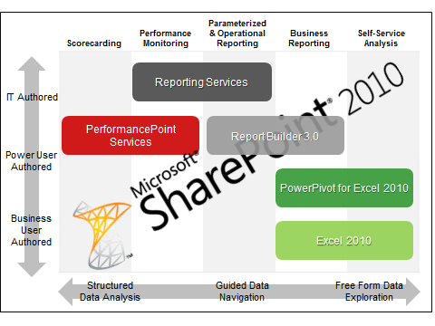

Figure 7 - Choosing the Right Microsoft BI Tool

# Additional Resources

**Web Sites**

* For more information on the Microsoft BI tools, please visit <http://www.microsoft.com/bi>.
* Microsoft Excel is the most widely deployed BI tool in the world for the Self-Service Analysis style. <http://www.microsoft.com/bi/productsbi/#excel>
* Power Pivot is a new product available as a free add-in to Excel 2010. <http://www.powerpivot.com/>
* Microsoft SQL Server 2008 R2 Report Builder 3.0 provides an intuitive report authoring environment for tech-savvy business users and IT professionals. <http://www.microsoft.com/sqlserver/2008/en/us/report-builder.aspx>
* Microsoft SQL Server Reporting Services provides a complete, server-based platform designed to support a wide variety of reporting needs. <http://www.microsoft.com/sqlserver/2008/en/us/reporting.aspx>
* The PerformancePoint Services component of Microsoft SharePoint Server 2010 is a performance management service that is used to create dashboards and scorecards. <http://technet.microsoft.com/en-us/library/ee661741.aspx>

**Case Studies**

* Chevron: <http://www.microsoft.com/casestudies/case_study_detail.aspx?casestudyid=4000007043>
* Charlotte-Mecklenburg Schools: <http://www.microsoft.com/casestudies/Case_Study_Detail.aspx?CaseStudyID=4000002234>
* Schumacher: <http://www.hitachiconsulting.com/files/pdfRepository/CS_SchumacherGroup.pdf>
* Bank of America:

<http://www.microsoft.com/casestudies/Case_Study_Detail.aspx?CaseStudyID=4000002415>

Please view additional case studies on: [http://www.microsoft.com/bi/biresources/#](http://www.microsoft.com/bi/biresources/)